**Lab 5 Design Record Document**

**Luke Garland** 30046672

**Aidan Johnson** 30043501

December 4, 2019

RTL:

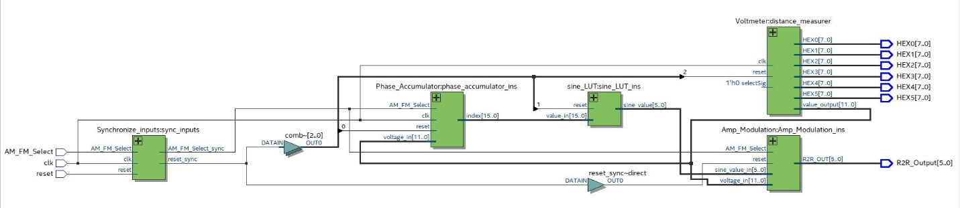

# Timing:

